ELA Vocabulary Quiz #4
Part #1
Directions: Match the vocabulary term to the correct definition by writing the letter of the definition on the space provided before each term.

______ Ethnicity

______ Procrastinate

______ Onomatopoeia

______ Trade

______ Homograph

______ Christianity

_______ Europe

A – socially defined category of people who identify with each other based on common ancestral, social, cultural or national experience
B – exchange of one's goods and services for desired goods and services that someone else possesses
C - the religion based on the person and teachings of Jesus of Nazareth, or its beliefs and practices
D - continent of the Eastern Hemisphere between Asia & the Atlantic Ocean
E - each of two or more words spelled the same but not necessarily pronounced the same and having different meanings and origins
F - the formation of a word from a sound associated with what is named
G - delay or postpone action; put off doing something
Part #2
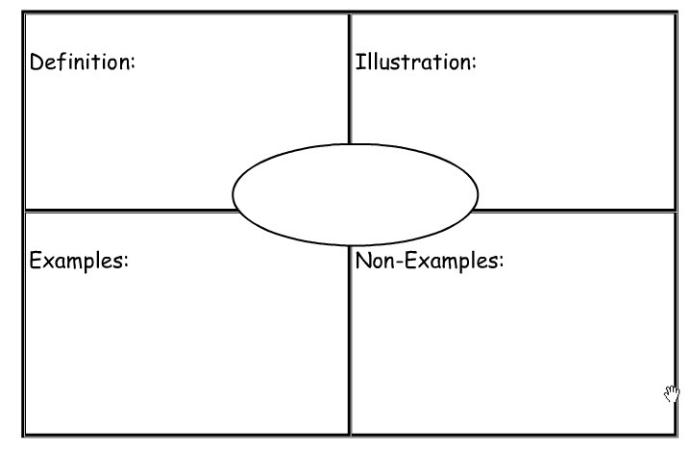
Directions: Using the Frayer Model below, pick one of the vocabulary terms above and fill out the model to the best of your ability. The term goes in the middle circle. Rewrite the definition in your own words. Illustration is a drawing to show understanding of the term. Provide examples and non-examples as well.

