ELA Vocabulary Quiz #3
Part 1 Directions: Using the definitions provided below, write the term in the correct spot within the crossword puzzle. Make sure you are spelling the terms correctly. Look elsewhere on the quiz to see how each term is spelled.

Across
4. What people do or show towards other to show they are polite.
5. When people do things with nature. These could be positive and/or negative.
Down
1. Occurred at Chernobyl, Ukraine. Spread radiation across Europe.
2. Has to do with the mapping of the earth. Math for geography.
3. Something that negatively impacts nature. Usually caused by humans. Acid rain,
air pollution, and nuclear disaster are examples.

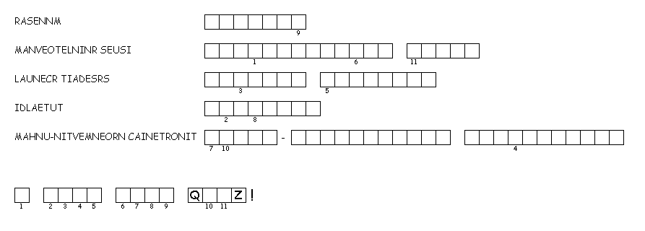
Part 2 Directions: Unscramble the vocabulary terms below into the boxes provided. Once all terms have been unscrambled, copy the letters of the numbered cells to other cells with the same number.

Message of Encouragement

Part 3 ELA1 Directions: Write a sentence using each vocabulary word correctly in that sentence. To receive full credit I must be able to understand the words meaning from the sentence.
Part 3 ELA2 Directions: Write a sentence using any four vocabulary words correctly in that sentence. To receive full credit I must be able to understand the words meaning from the sentence.
Latitude –

Human-environment interaction –

Manners –

Nuclear disaster –

Environmental issue –

Part 4 Directions: Write a comic strip using one of the vocabulary terms from this quiz. You may use the squares provided but are able to draw more should you need them. Feel free to use the blank space provided to add more blocks or shapes for your comic strip.

