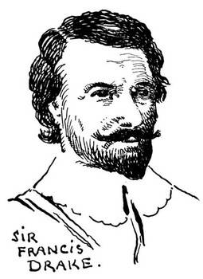 | Sir Francis Drake
 | Born: 1540 | Died: 1596
 | English Explorer

Major Accomplishment
He helped defeat the Spanish Armada, and he was the first Englishman to sail around the world.

Early Life
I was born in 1541 in a cottage made of rough tree branches on a nobleman’s estate in the country of England. The estate was located in Tavistock, twenty miles north of the seaport of Plymouth. I am the oldest of eleven brothers. My father, Edmund, was a Protestant farmer. He was a sailor before my brothers and I were born.

My Adventures Begin
When I was 18, I started serving in ship trading to the Bay of Biscay. At 23, I went on slaving voyages to Guinea in West Africa. At 24, I was made captain of the Judith. On the Judith, I went on an expedition against the Spanish Main in the West Indies and Central America. Most of my ships were sunk by the Spaniards at San Juan Ulua, but I escaped.

Attacking the Spanish Main
In 1570 I returned to the Spanish Main to get revenge, and for 3 years I made myself a hated person there. I realized that Panama was a weak part of the Spanish Empire. All the goods and silver from the colonies on the west coast of South America had to be carried on mules across this neck of land to be shipped from Nombre de Dios to Spain. I plundered the towns of Vera Cruz, Portebello, and Nombre De Dios in Panama. I crossed the neck of land known as the Isthmus of Panama. From there I saw the Pacific Ocean, and I resolved to sail an English ship in that sea someday.
When I arrived back in Plymouth Harbor in 1577, I was both rich and famous.

Sailing Around the World
In December of 1577, I set off on the Golden Hind on my trip around the world. I had the best-equipped expedition ever launched by England--5 stout ships, well-armed, and a crew of 150 men. We reached the coast of Brazil in April of 1578. On May 21st we entered the Straits of Magellan at the southern tip of South America.
We turned northward and sailed up the coast of Chile and Peru attacking and destroying Spanish ships. We continued north along the coastline, exploring as far as Vancouver, Canada. Then we sailed across the Pacific Ocean to the Celebes and Java, and still westward to the Cape of Good Hope at the southern tip of Africa.
We crossed the equator in July and sailed into Plymouth Harbor in September of 1580. I returned with one ship and a half-starved crew of 58 men who had not set foot on a populated shore for 6 months. The ship carried the richest cargo ever to reach an English port. There were spices, precious metals, jewels, silks, fine porcelains, and irreplaceable maps.
I was the first Englishman to sail in the Pacific Ocean, Indian Ocean, and south of the Atlantic Ocean. I was the first Englishman to sail around the world, and I was the first European to see the west coast of Canada.

The End Is Near
In 1596, I went again to the West Indies and Central America where I got dysentery. On January 27, 1596, I asked a crewmember to help me in my armor. I said, "I was going to sleep."

Editor’s Note
A crewmember of Sir Francis Drake tells how the next morning Drake was found dead. The crew put his body on his ship and lit it on fire for a sea burial.

