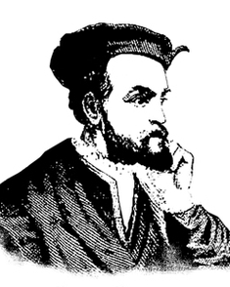 | Jacques Cartier
 | Born: 1491 | Died: 1557
 | French Explorer

Major Accomplishment
He discovered the St. Lawrence River.

Early Life
Jacques Cartier was born in the seaport of Saint Malo, France. He studied navigation in Dieppe, a major French center for navigators. After that he became a highly respected navigator. He may have sailed to Newfoundland with a fishing fleet in the early 1500s. Some historians believe Cartier accompanied Giovanni de Verrazano on French expeditions to the New World.

In Search of the Northwest Passage
In 1531, Francis I commissioned Cartier to look for the Northwest Passage, the short route to the Pacific Ocean that had eluded John Cabot in 1497. Cartier got two small ships and 61 crew members. He left Saint Malo in April. In less than three weeks, he was sailing down the coast of Newfoundland, discovering islands. They then crossed the Gaspe Peninsula and took possession of it for France before returning home. Unfortunately he had mistaken the mouth of the St. Lawrence River for a bay, and failed to investigate it. Cartier’s description of the distant land excited many young explorers to seek their fortune in the New World.

Second Expedition to Canada
In 1535, the king sent him out again. He sailed up the St. Lawrence River and recognized it for what it was. He continued on, establishing Mont Real (Mount Royal) which is now Montreal, Canada. They spent the winter at an Indian village near Quebec, where Cartier watched 25 of his men die of scurvy. The Huron were generous to him, but he betrayed them. He kidnapped 12 Indians, including their chief, and headed straight for France. Cartier hoped that his prisoners would tell him where their gold mine was located, but there really was no gold mine.

Last Voyage to the New World
In 1541, his third expedition was put together to help Jean Roberval found a colony in Canada. Failing to find enough French colonists willing to give up the advantages of home for the uncivilized New World, Roberval asked his government to help. It met his needs by freeing from prison anyone willing to join the expedition. While Cartier went ahead, Roberval awaited his recruits. In June 1544, Roberval arrived on a supply ship only to find that Cartier had slipped back to France. Cartier had left Roberval stranded in New France with a colony of robbers and murderers.
Cartier never found the Northwest Passage, but his explorations served as a basis for the French claims in the rich St. Lawrence Valley and led to many future expeditions by France to Canada.

