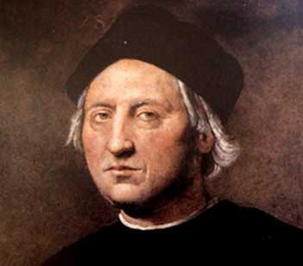 | Christopher Columbus
 | Born: 1451 | Died: 1506
 | Spanish Explorer

Major Accomplishment
He was the first European since the Vikings to "discover" the New World.
The Journal of the Admiral of the Ocean Sea
July 15, 1492
As I prepare for my expedition to the Indies, I wanted to write about my life so far so that when I return triumphantly, everyone shall remember my greatness!
My name is Cristoforo Colombo, but most people know me as Christopher Columbus. I was born in Genoa, Italy in 1451, the oldest of five children. I was an obedient son.
I had little schooling, so I did not learn to read or write as a young boy. But I always loved the sea. I vowed as a young boy that as soon as I was old enough, I would go to sea.
I was fascinated by Marco Polo’s accounts of his journey to Asia in 1271. I believe that the quickest and most direct route to this fascinating place is to cross the unknown waters that we call the "Sea of Darkness."
August 3, 1492
The rulers of Spain gave me three ships—the Niña, the Pinta, and the Santa Maria. They also paid for 90 crewmen and supplies.
October 12, 1492
We have spotted land! I have named it San Salvador. I believe that Japan is only a short distance to the west. [Editor’s note: Columbus landed in the Bahamas south of Florida. He believed that he was on islands off the coast of Japan.]
There are strange looking people here, very different from my men and me. They wear little clothing and are of a different color. Our giant ships with enormous white sails amaze them. These Indians are not what I expected, and there are no cities of gold like Marco Polo described. [Editor’s note: Columbus had actually met members of the Taino tribe, but he believed he was in the Indies. This is why he called them Indians.]
I spotted several of them wearing GOLD! They tell me that islands to the north and south are where the gold will be found, so I ordered my men to set sail for the gold!
December 5, 1492
We searched many different islands, but we found only more Indians. There were no cities and no gold. We traveled north to a much larger island, but still more Indians and no gold. The King and Queen will not be happy if I do not find gold!
March 15, 1493
We sailed back across the Ocean Sea. Despite terrible storms, my navigation skills have brought us back to Spain. I have received a letter from the king and queen. They have named me Admiral of the Ocean Sea and the governor of all of the islands that I discovered. News of my discoveries has traveled across Europe. My voyage is known by all, and I am a hero! I am anxious to return to the land that I discovered because I still have not found the gold that I know is there.
[Editor’s note: Columbus died on May 20, 1506, never getting to the Indies. Still, Columbus may have been the greatest sailor of his time. He sailed across almost 5,000 miles of ocean and was able to find the same island over and over, without the knowledge of how a compass worked or an accurate map. He was the first European to travel to the island of the Caribbean Sea, and he would touch on South America and Central America. He never made it to the United States, but he did make it as far north as Cuba, only 90 miles from Florida.]

