Pack Your Bags!
Directions:
- Inside of the suitcase, draw FIVE things that you are going to take with you on our class trip to Africa. Think about the location, climate, physical features, natural resources, and cultures of the continent. Look in your notes for clues about what you might need on your trip.
- Next, include a brief description of why you chose to bring that particular item.
Example)
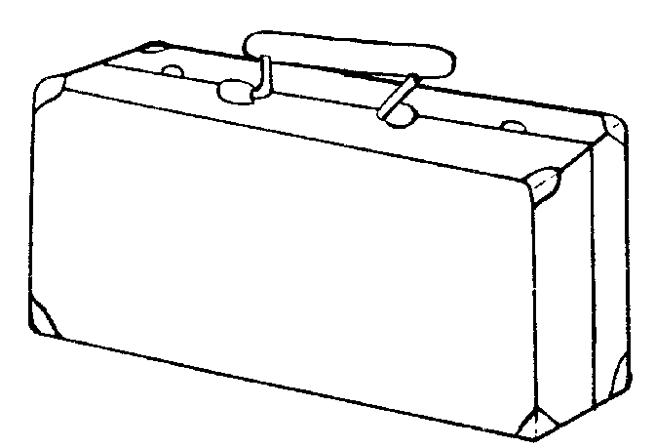
I’m bringing a camera to take a picture of the meerkats in the Kalahari Desert.
- Color your suitcase, cut it out, and write your name on the back.

