Sierra Madre Mountains

The Sierra Madre Mountains runs down the northwest and southeast portion of Mexico. The Sierra Madre Mountains are made up of smaller ranges, including Sierra Madre Oriental, Sierra Madre Occidental and Sierra Madre del Sur. The Sierra Madre, ranges from around 6,000 feet to 12,000 feet above sea level
LINK: https://youtu.be/wD3oc75rmWk
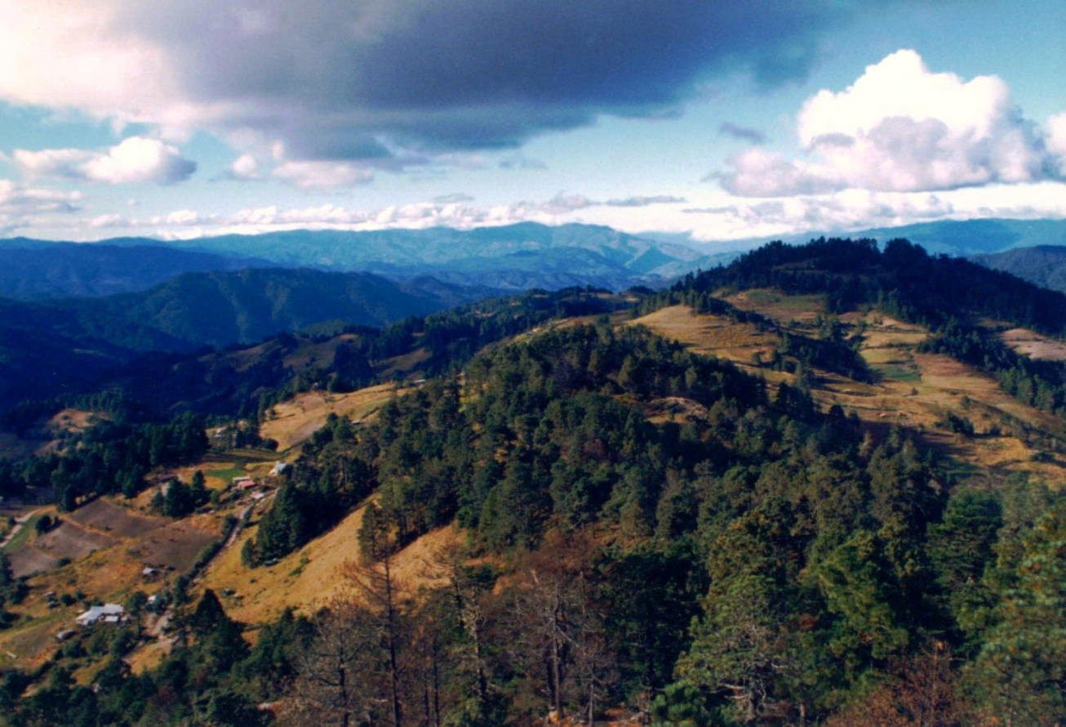

Gulf of Mexico
The Gulf of Mexico is located at the south eastern corner of North America bordered by Mexico, Texas, Louisiana, Mississippi, Alabama, and Florida. The Gulf of Mexico is 617,763 sq miles big. The greatest distance across the Gulf is approximately 1,000 miles going east to west.
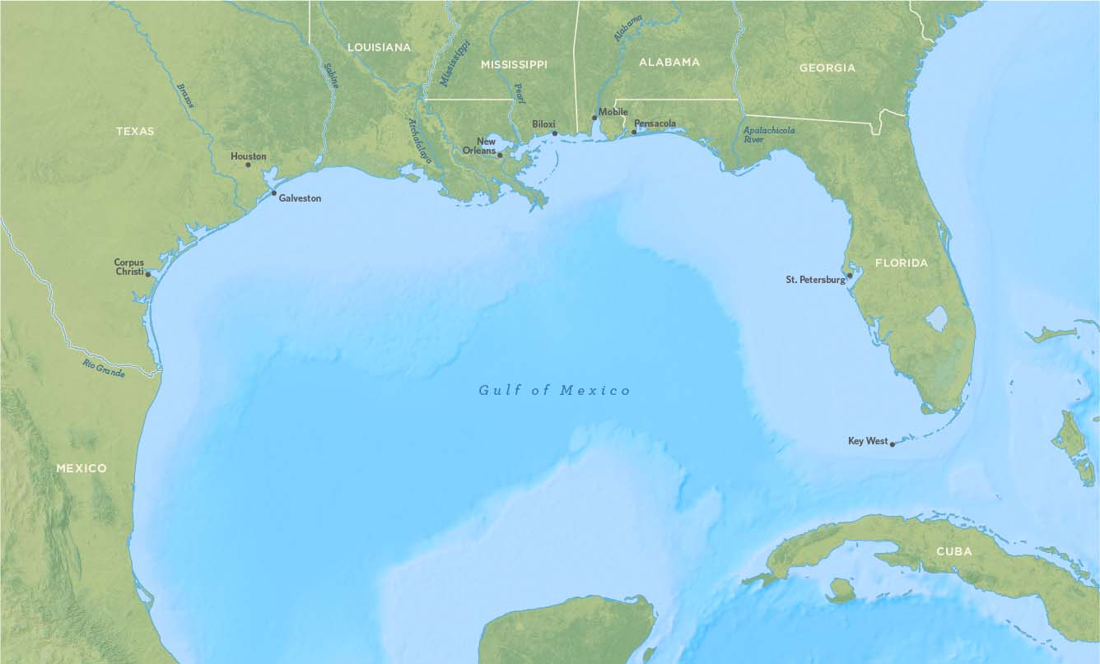
Link: http://www.gulfmex.org/about-the-gulf/gulf-of-mexico-facts/

Cuba
Cuba is located directly south of Florida. It is 42,426 mi² big. Cuba is the largest of all islands in the Caribbean. The United States had a strong influence over the island until 1959, when communist revolutionaries, led by Fidel Castro, took over. The country remains one of the world's four self-declared communist states today.
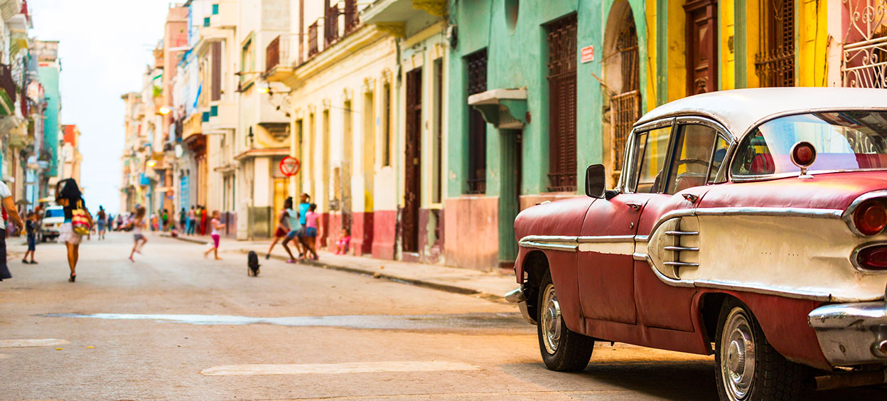
Link: http://www.sciencekids.co.nz/sciencefacts/countries/cuba.html

Panama Canal
The Panama Canal cuts across of Panama providing ship passage between the Atlantic and Pacific Oceans. The length of the Panama Canal from shoreline to shoreline is about 40 miles. The Panama Canal is an artificial 48-mile waterway in Panama that connects the Atlantic Ocean with the Pacific Ocean.
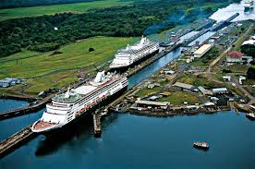
Link: http://www.history.com/news/7-fascinating-facts-about-the-panama-canal

Andes Mountains
The Andes Mountains are located along the western edge of South America. They are the longest mountain range in the world. The Andes extend from north to south through seven South American countries: Venezuela, Colombia, Ecuador, Peru, Bolivia, Argentina and Chile.
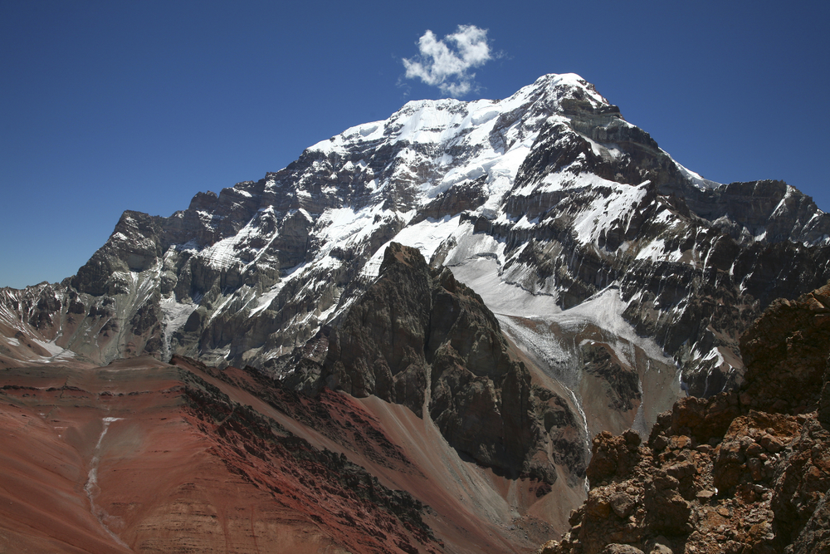
Link: http://www.livescience.com/27897-andes-mountains.html

Amazon River

The Amazon River, located in South America, is the second longest river in the world. It flows through Guyana, Ecuador, Venezuela, Bolivia, Brazil, Colombia, and Peru making the distance about 4,000 miles or about 6,400 kilometers.
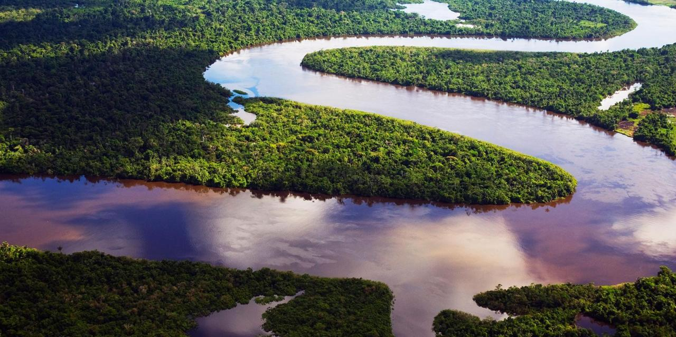
Link: http://www.extremescience.com/amazon-river.htm

Amazon Rain Forest

The Amazon rainforest is located in northern South America, in the country of Brazil. It covers 2,300,000 square miles and makes up about 40 percent of the geographic area of Brazil. The Amazon rainforest has a tropical climate that is hot and humid throughout the year. The average annual temperature is usually around 80 degrees Fahrenheit.
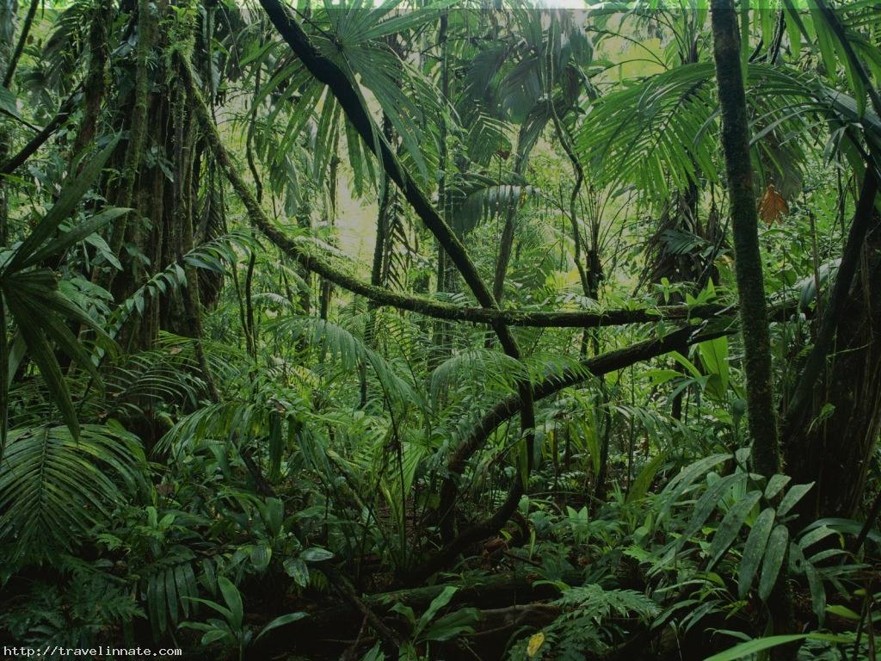
Link: https://en.wikipedia.org/wiki/Amazon_rainforest

Atacama Desert
The Atacama Desert is located on the western coast of South America, right along the Pacific Ocean. It stretches nearly 600 miles from the southern border of Peru into northern Chile. The Atacama is the driest desert in the world.

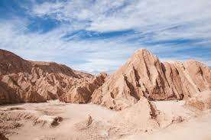
Link: https://www.quasarex.com/blog/10-facts-atacama-desert

Mexico
Mexico is located in North America; it is south of the United States and north of Central America. Mexico is 758,400 mi² big. Mexico is the 11th most populated country in the world with around 117 million people (as of July 2012).
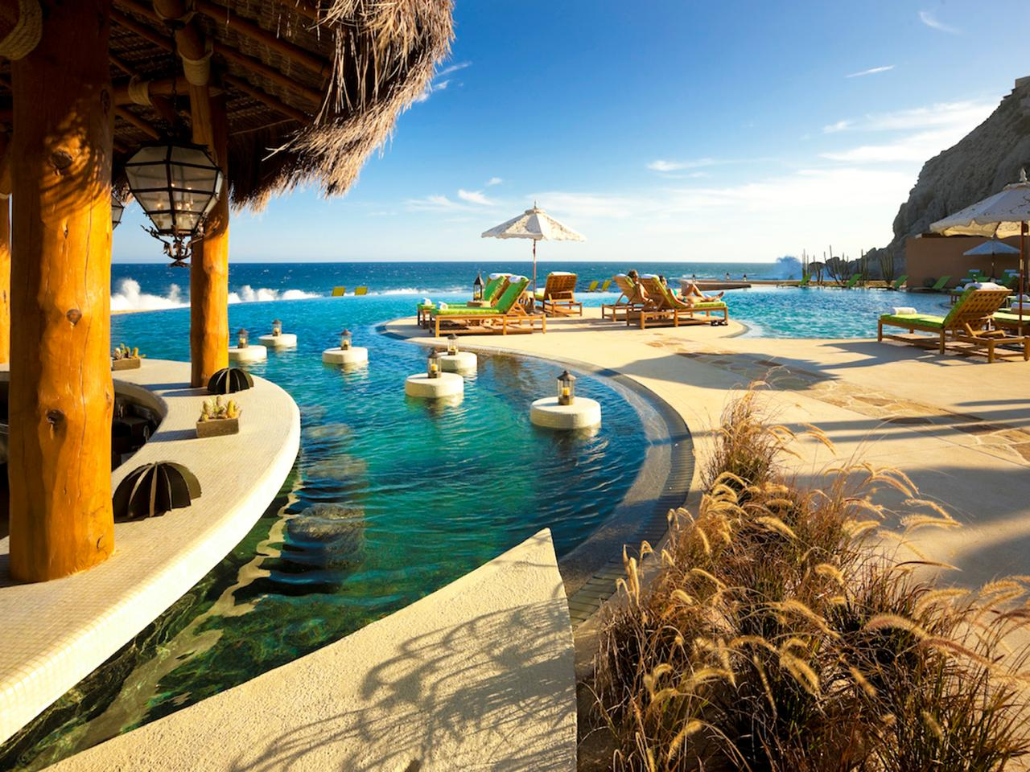
Link: https://www.factretriever.com/mexico-facts

Haiti
Haiti is a small island country that is located in the Caribbean between Cuba and Puerto Rico. Haiti and the Caribbean are located between North and South America, and they are surrounded by the Atlantic Ocean and Caribbean Sea. Haiti is 10,714 mi² big.
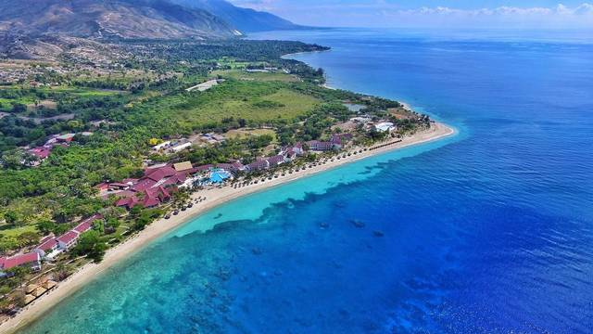
Link: http://www.cnn.com/2013/10/17/world/americas/haiti-fast-facts/

Panama
Panama is located to the south of Columbia and to the north of Costa Rica in Central America. Panama is at the southern end of Central America isthmus, which is a narrow piece of land connecting two larger pieces of land. Panama is ‎74,340 km² big.
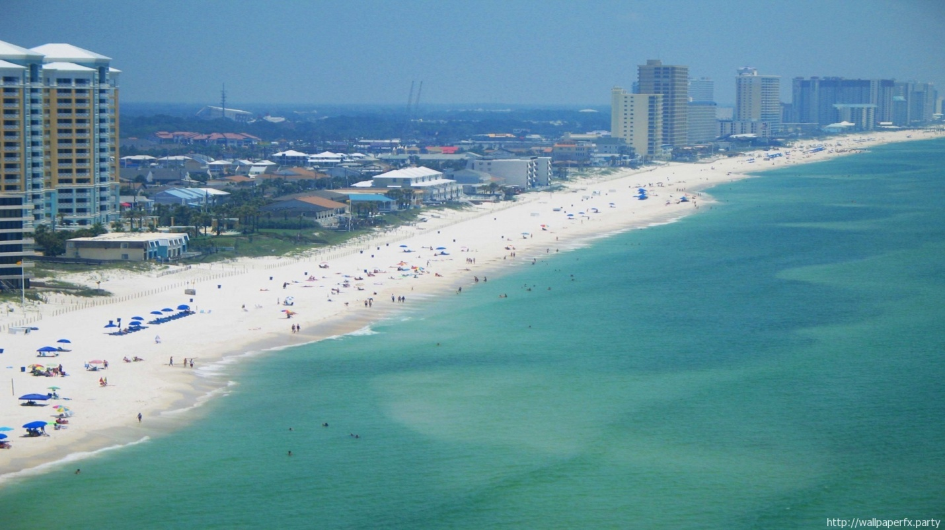
Link: http://www.latinamericacollection.com/panama/about/basic_facts.html

Colombia
Colombia is in the northwest corner of South America and has coasts on both the Caribbean Sea and the Pacific Ocean. Colombia is 440,800 mi² big. Colombia is the only country in South America that has a coastline on both the Pacific Ocean and the Caribbean Sea.
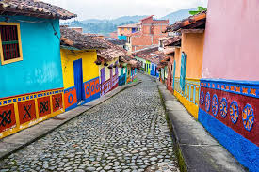
Link: http://www.sciencekids.co.nz/sciencefacts/countries/colombia.html

Venezuela
Venezuela is located on the northern coast of South America, covers an area of 912,050 sq km. Venezuela is the 33rd largest country in the world by land mass. The world’s tallest waterfall, Angel Falls, is located in Venezuela.
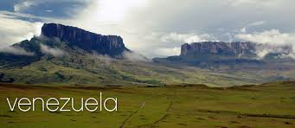
link: http://www.nationsencyclopedia.com/Americas/Venezuela-LOCATION-SIZE-AND-EXTENT.html#ixzz4ZZarvVtA

Brazil
Brazil is located on the east coast of South America. Its eastern side borders the Atlantic Ocean. It is south of Venezuela, Guyana and Suriname, southeast of Colombia, east of Bolivia and Peru, northeast of Argentina and Paraguay, and north of Uruguay. Brazil is 3.288 million mi² big.
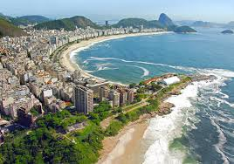
Link: http://www.sciencekids.co.nz/sciencefacts/countries/brazil.htm/

Bolivia
Bolivia is located in the central portion of South America, southwest of Brazil. It is a landlocked country bordered by Argentina, Brazil, Chile, Paraguay and Peru. Bolivia is 424,200 mi² big.
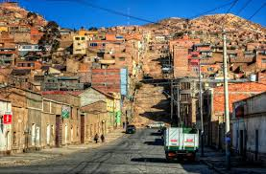
Link: http://www.factslides.com/s-Bolivia

Chile
Chile is located in South America It lies on the west coast of the southern half of the continent. Chile is a narrow strip of land that borders Argentina to the east, Bolivia and Peru to the north, and the Pacific Ocean to the west. Chile is 291,933 mi² big.

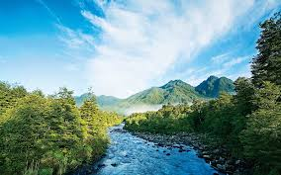
Link: http://www.sciencekids.co.nz/sciencefacts/countries/chile.html

Air pollution in Mexico City
The majority of the population is exposed to daily to fumes produced by 3.6 million vehicles. The city is situated at 2,240 meters above sea level, and because there's less oxygen at this altitude, most of the air pollution is the result of incomplete combustion of hydrocarbons, mainly diesel emissions.
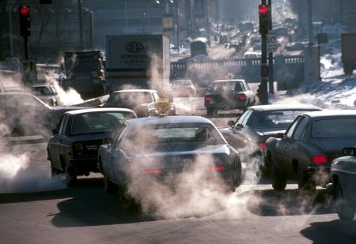
Link: https://en.wikipedia.org/wiki/Air_pollution_in_Mexico_City

Deforestation in the Amazon
Deforestation is happening because, Amazon rainforest is seen as a resource for cattle pasture, valuable hardwoods, housing space, farming space (especially for soybeans), road works (such as highways and smaller roads) and medicines.
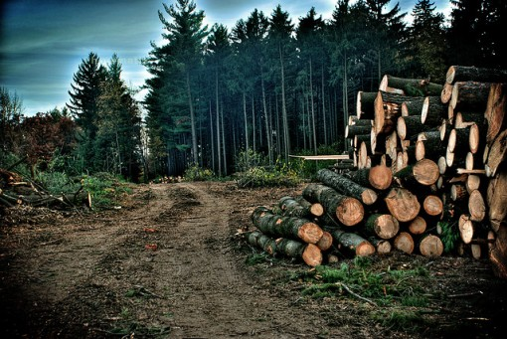
Link: http://rainforests.mongabay.com/amazon/amazon_destruction.html

Oil pollution in Venezuela
The cause of air pollution in Venezuela is, prolonged oil production has taken its toll on the county's environment. There is significant oil pollution along the Caribbean coast and Venezuela is the region’s top emitter of carbon dioxide.
