When we went on the trail at school it was amazing.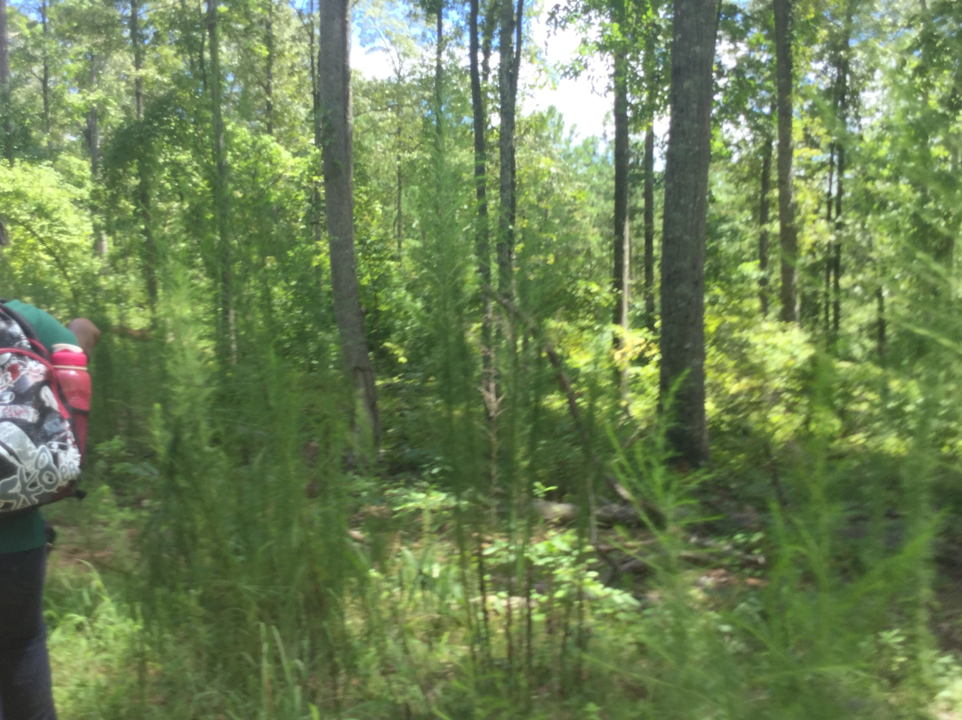We got to see waterfalls and animals.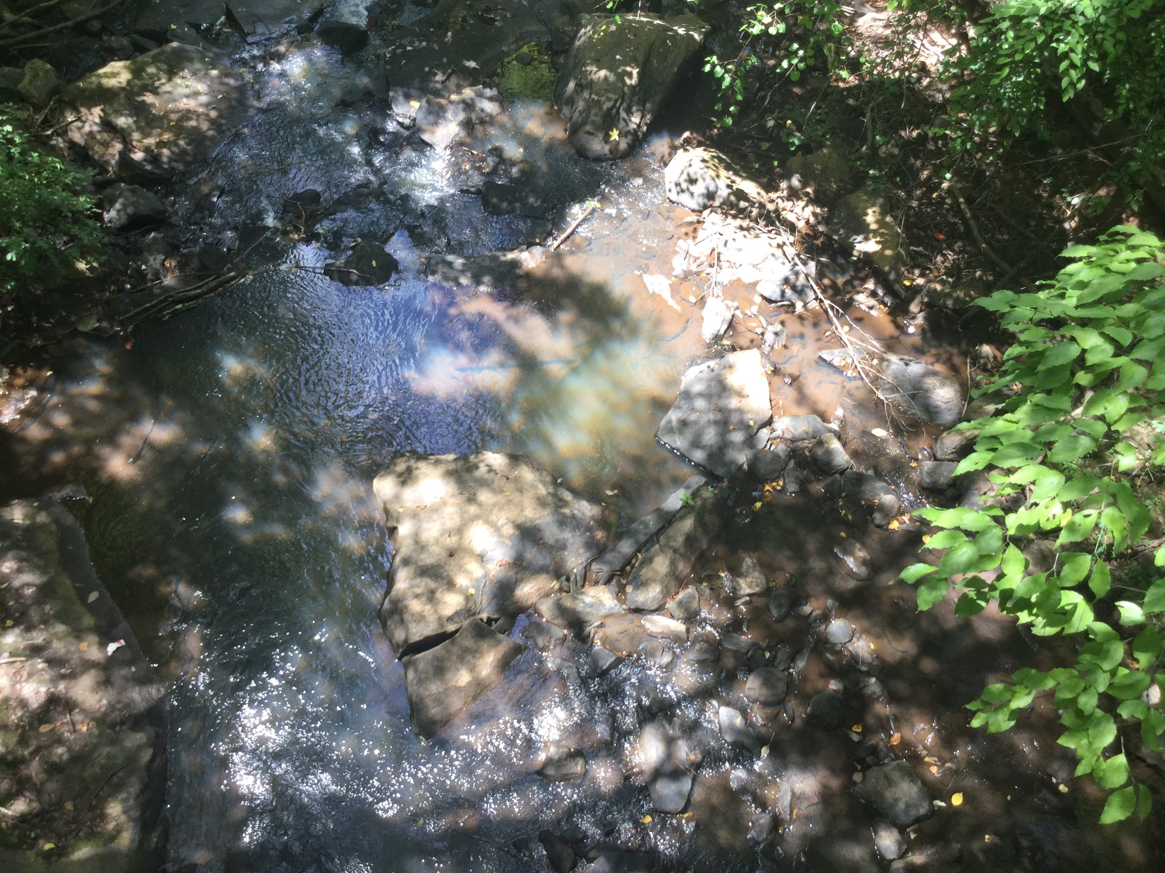While we were on the trail we had to take pictures of hazards.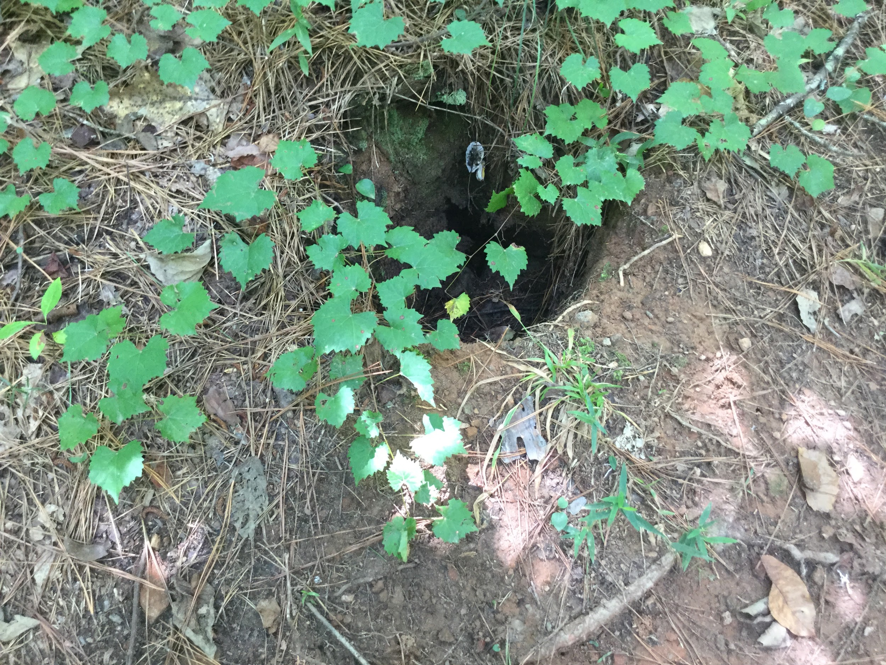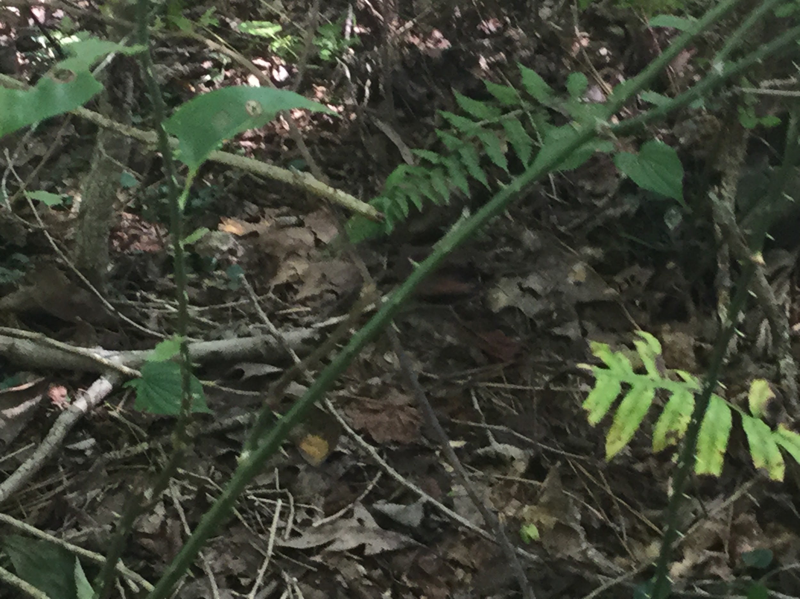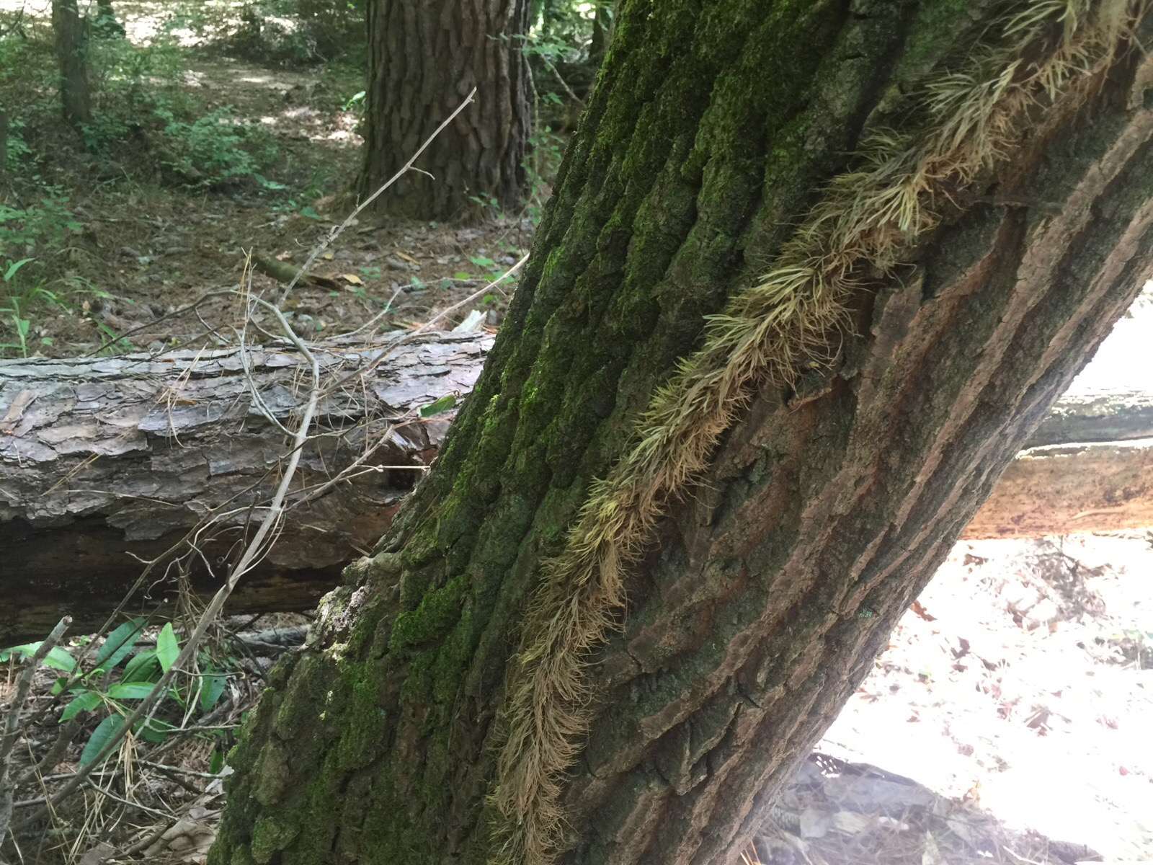There are many hazards in the woods that we should look out for.But it is still very important to have fun.So make you hike with a partner and stay safe.Also it is important to bring lots of water,if you get dehydrated you might pass out.

