Unit 3 – European Governments Quiz
Directions: Complete the quiz to the best of your ability. This quiz focuses on the systems and forms of government within our world. Think carefully and take your time. Use the information in the chart below to answer the questions.
Government Systems | Government Forms
1.  2.  3. | 1.  2.  3.

Part #1 – Select the best possible answer to the questions
- What is the form of government that allows only a small group of people to participate called?
  - Democratic
  - Autocratic
  - Oligarchic
  - Federal
- Which of these is a form of government and has to do with participation in the government?
  - Presidential
  - Monarchy
  - Democratic
  - Federal
- When Mr. Schilling decides to give his students assigned seats and doesn’t ask for their input. He is demonstrating which form of government?
  - Monarchy
  - Autocratic
  - Democratic
  - Parliamentary
- If power is divided between one central and several regional/state governments what system would we be talking about?
  - Federal
  - Unitary
  - Confederation
  - School
- Who elects the Prime Minister in a parliamentary democracy?
  - The citizens
  - The parliament
  - Both a and B
  - None of the above

- Which of the following tell us who has the power?
  - Unitary, federal, confederation
  - Democratic, oligarchic, autocratic
  - President and parliament
  - Monarch and dictator
Part #2 – Fill in the blank with the correct system or form of government from the chart
1. Germany and Russia have a __________________________ system of government that shares power between the central and regional/state governments.
2. Levi took control of the classroom. He is very nice to his students but in the end, he has the final say on anything that happens. Levi is ruling an ___________________________ classroom.
3. Mr. Robinson and Mr. Schilling work together to run the sixth grade. They are part of the sixth grade teaching team which is an example of an ___________________________ government.
4. If power is distributed from the regional governments in the European Union, then the European Union has a _____________________________ as their type of government.
5. Michael and Kennedy have taken over the school! They use the kindergarteners as a police force to make sure their rules are enforced. Together they are an ___________________________ government. Luckily for CHCS, they do listen to the rest of us and take our opinions into consideration so the power is shared in a way. This means that CHCS has a _______________________ system of government under the rule of Michael and Kennedy.
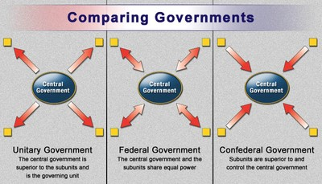
Part #4 – Fill in the missing system of government from the diagram below

