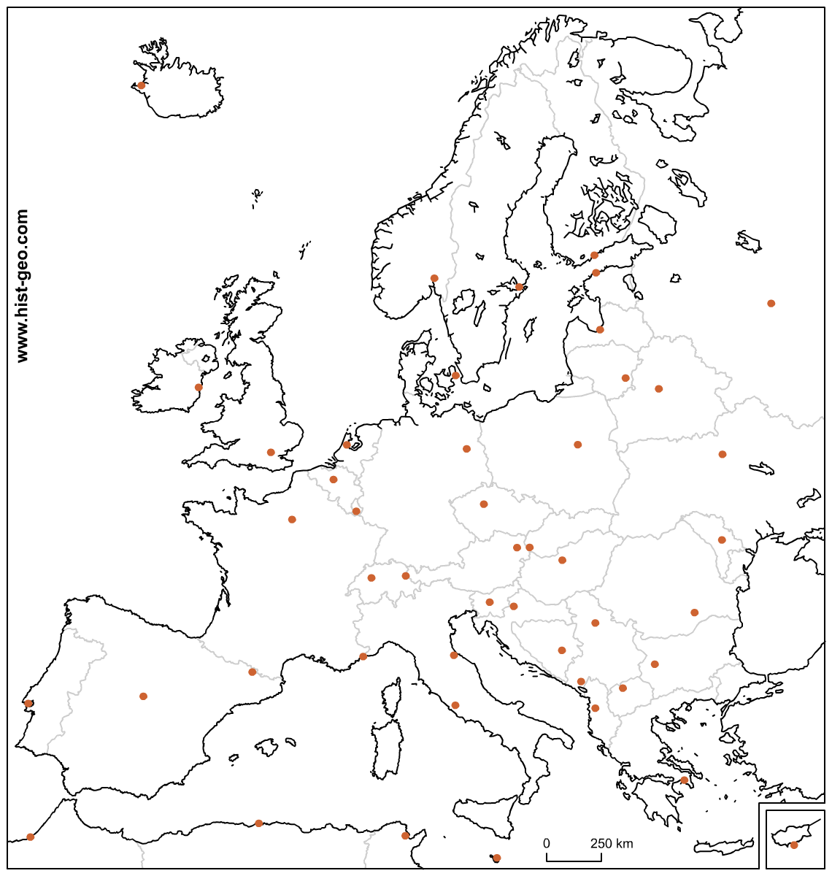
Locate the European countries listed on the board on your map, and shade them in lightly. Then, write a paragraph about how these countries might benefit from being in alliance with each other (politically, economically and socially).
_________________________________________________________________________________________________
__________________________________________________________________________________________________
__________________________________________________________________________________________________
__________________________________________________________________________________________________
__________________________________________________________________________________________________
__________________________________________________________________________________________________
Notes:
What is the European Union?
In your opinion, why would countries want to unify themselves together?

What are the 5 goals of the European Union?

What is sovereignty?

What is Nationalism?
What could the European Union do to Nationalism?
Describe the effect the European Union could have on various cultures?
What are some costs that come from being in the European Union?
Should the United States create a similar unification with Mexico and Canada? Back up your opinion with evidence or support.

