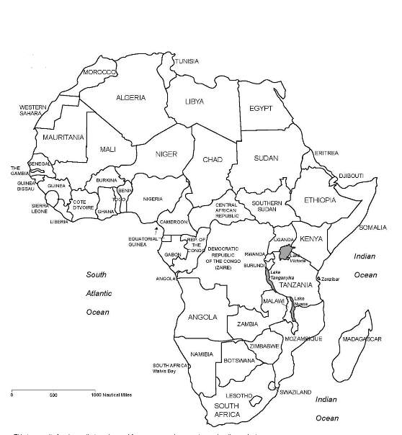
European Partitioning in Africa

Directions: Create a color-coded key for the Colonizing Countries. Next, color the countries below to correspond with the countries that colonized them. Finally, answer the 3 questions using the chart!

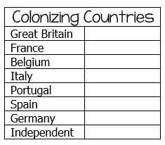

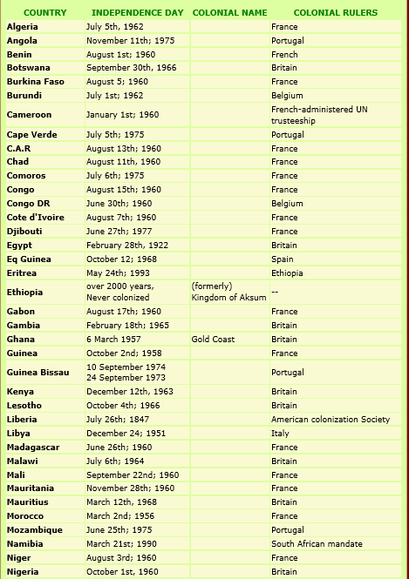

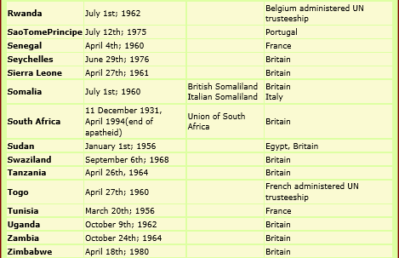

- Which country had the most colonies in Africa?

- Which countries were never colonized?

- What effect did colonization have on the native peoples of Africa?

