Name ___________________________
Date _____________________
European Exploration Comic Book
Create a comic book of a European explorer of your choice. You may choose any explorer from Europe. Please make sure the explorer you select was born in Europe!!! On a sheet of paper please create your comic book. The comic book does not have a required length but should cover all of the required material below.
Make sure you include the following elements to your comic strip:
______ Title (2 pts)

______ Explorer clearly identified (3 pts)

______ Why are they exploring (5 pts)

______ Location headed to explore clearly stated (5 pts.)

______ Country of origin clearly stated (5 pts)

______ Date explorer explored (5 pts)

______ Colored and organized (5 pts) _______ Total Points

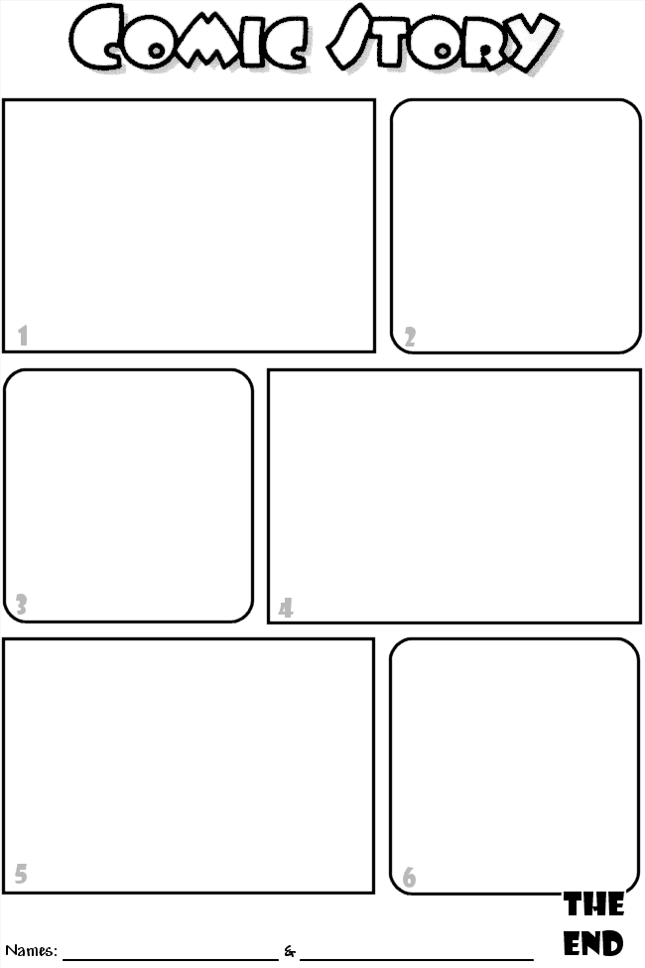

This is an example template for your comic strip.

*I found it on Google in case you wanted to print it out from home*

