Environmental Issues Postcard
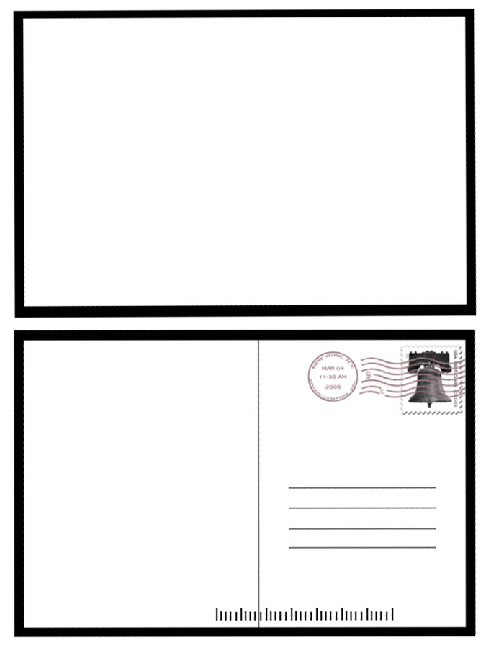
Directions: Which environmental issue are you most concerned about? Write a postcard to a friend who lives in the country where the problem is occurring. On the front of the postcard, draw an illustration of the environmental concern. On the back, describe what’s happening in the concern and what you think the country’s government should do to fix it.

