Environmental Issues
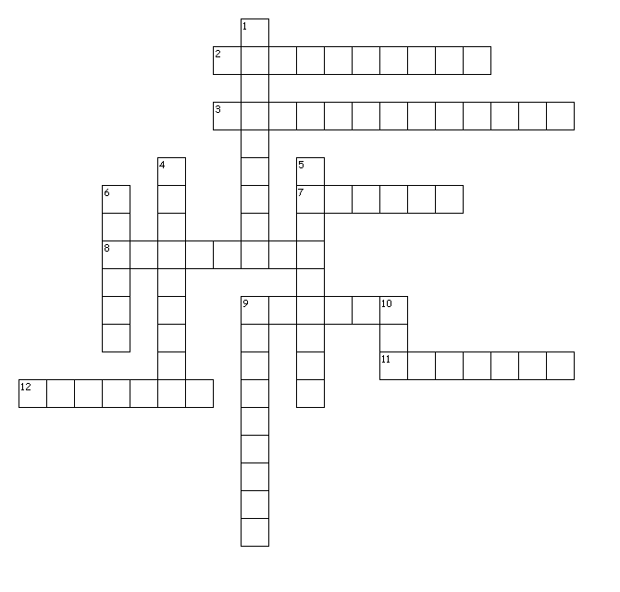
Across
2. place where air pollution is an issue
3. cutting down lots of trees
7. why deforestation is bad for people
8. air pollution can lead to this issue
9. what deforestation harms
11. what deforestation harms
12. european country where air pollution was a big problem
Down
1. place where oil is polluting the caribbean sea
4. sea where oil is being polluted
5. block the wind from blowing away the air pollution in mexico city
6. place where amazon is getting cut down
9. introduction of contaminants into the natural environment that harm it
10. oil is found here

