Early History of Latin America Response to Reading CLASS SET
TASK: After reading the “Early History of Latin America Reading” please answer the following questions on your own paper. Make sure to write in detailed complete sentences and RESTATE THE QUESTION (RTQ). Be sure to answer using specifics from the text. Avoid using pronouns, words that take place of a noun. An example of using pronouns: He conquered the Inca. Instead write using proper nouns: Pizarro conquered the Inca. All questions can be answered using the reading provided to you as well as using prior knowledge and a dictionary.
Aztec
1. Where was the Aztec Empire located?
2. Explain how the Aztec government was made up.
3. What if the Spanish conquistadors had never sailed to North and South America. How do you think things would be different today?
4. Explain why Montezuma II did not attack Cortes and the Spanish when they arrived in Mexico.

Inca
5. Define masonry.
6. Explain how the Incan people were connected to the Sapa Inca.
7. Provide detailed support for this statement, “Atahualpa wanted to die a Christian”.
8. Analyze the achievements of the Inca. Rank the five achievements listed from most important to least important and provide support for each ranking.

Spanish
9. Compare and contrast the lives of Hernan Cortes and Francisco Pizarro.
10. Create your own question from this section of the reading. Make sure to write down your question as well as the answer to your question.

Columbian Exchange
11. What was the Columbian Exchange?
12. Predict what could have happened differently if the natives of North and South America had been immune to diseases like smallpox.
13. Provide a detailed explanation of how the Exchange impacted regions around the world.
14. Design and create a drawing that depicts the exchange of goods between the New World and the Old World.

Connections
15. Use what you know to convince me how impactful the Spanish have been on Latin America.
16. Make a connection between what you’ve read about early Latin American history and the history of Europe.

MORE QUESTIONS ON THE BACK
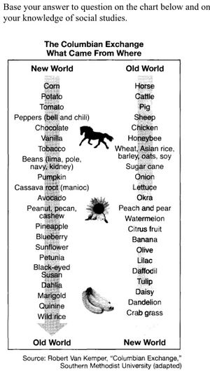
Image Analysis
Use the chart to the right to answer the following
questions:
17. What are four food items originally from the
Americas?
18. What are four food items originally from
Europe, Africa, and Asia?
19. Is the pumpkin originally from the New World
or the Old World?
20. What animals from the Old World had a major
impact on the New World?

Use the image below to answer question 21:
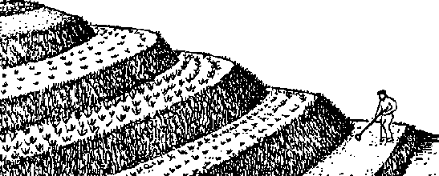
21. Which style of farming is this?

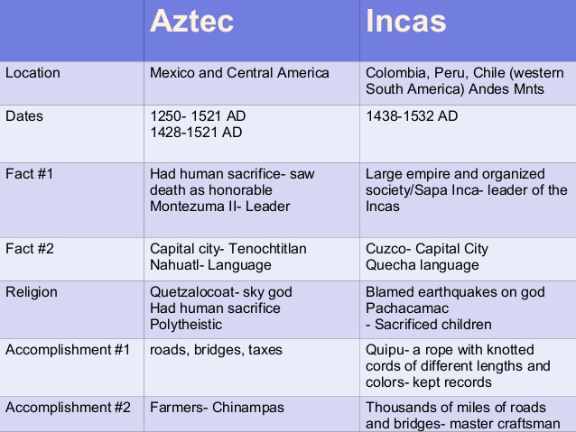

Use the chart to the left to answer the following questions:
22. According to the chart, which empire lasted longer?
23. What were the capital cities and official languages of the Aztec and Inca?
24. According to the chart, the Aztec were great farmers. They created chinampas for farming. What are chinampas?

