Disney Movie Project
Demonstrating Understanding of Story Elements
This project is a final assessment for the elements of a story. Instead of taking a test, you will complete this project on your own. This project is due on January 6, 2016. If you don’t want to do work over the break, work on it before break begins! If you have any questions please do not hesitate to contact me at ben.schilling@chatthillscharter.org or view helpful information at my website http://schillingb.weebly.com/english-language-arts.html.
In order to complete this project, you will need to watch one animated Disney movie. Some movie suggestions include: Pixar movies like Finding Nemo, Aladdin, Jungle Book, and Cinderella. After selecting your movie, complete these assignments while you watch the film. I recommend having the remote handy so you can pause. If you don’t own any animated Disney movie, check one out at the local library or look for one online.

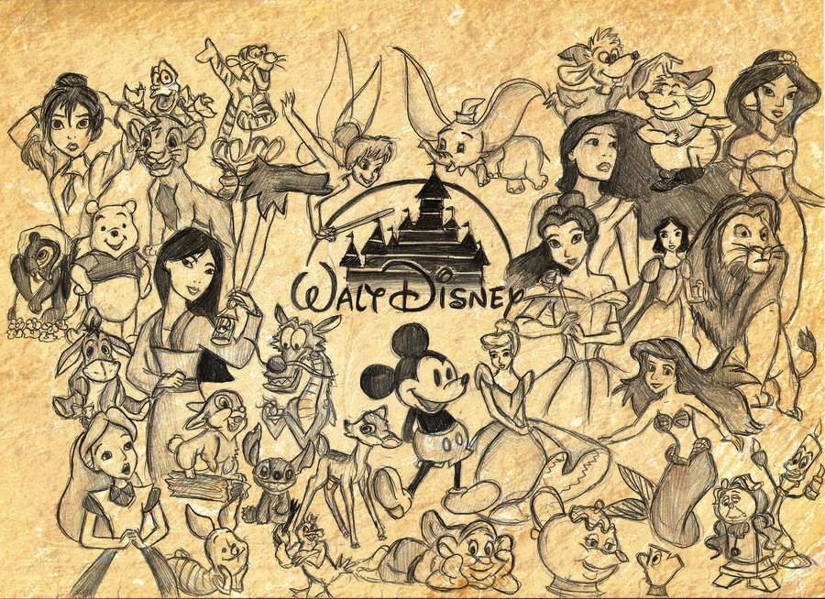
Project is due on January 6, 2016. This is the first day back to school for students.
Instructions & Rubric for Grading
Step 1. Design a front cover and attach it to the pages you receive in this packet. Include artwork and the name of the movie. Also make sure to include your name, the assignment title, and your class (ELA1 or ELA2).
Step 2. Label the plot diagram provided on page 3 by placing the following terms in the correct order: resolution, rising action, falling action, exposition, and climax.
Step 3. Within the boxes on page 4 label and explain each part of the movie’s plot (the first box is labeled for you).
Step 4. Write the definition of each italicized term and then answer the questions that follow (on pages 5-6). Make sure you are answering all questions in complete sentences. Definitions do not need to be in complete sentences.
Step 5. Choose one of the activities listed on page 7 and complete it following the directions given.

RUBRIC | 3 | 2 | 1
Step 1 – Cover | Includes all 5 elements from step instructions above | Includes only 3-4 elements from the step instructions above | Includes only 1-2 elements from the step instructions above
Step 2 – Plot Diagram | All 5 labeled correctly | 3-4 labeled correctly | 1-2 labeled correctly
Step 3 – Plot Described | All 5 labeled and explained correctly | 3-4 labeled and explained correctly | 1-2 labeled and explained correctly
Step 4 - Definitions | All terms defined and questions answered | Most terms defined and questions answered | Few terms defined and questions answered
Step 5 – Activity | Assignment completed fully | Assignment mostly completed | Assignment barely completed
Spelling | No more than five errors in spelling | Five-ten errors in spelling | More than ten errors in spelling
Grammar | No more than five errors in grammar | Five-ten errors in grammar | More than ten errors in grammar
Punctuation | No more than five errors in punctuation | Five-ten errors in punctuation | More than ten errors in punctuation
Neatness | Project is readable | Project has some areas that are hard to read | Project is very hard to read

Final Score: ____________________ / 27
Percentage: ____________________ %
Step 5: Activity
Directions: Pick one of the activities from the options below.
Activities
1. Draw a picture of a character from the film. You may decide which character to draw. I do not want a picture printed out. Draw it! Use color please. Use those art skills I’ve seen in your sketch books. After you have drawn the character, please write a paragraph or two explaining whether or not the character is a protagonist or an antagonist and why. Be sure to support your answer using detail from the film.
2. Create a movie poster for the film. This will look like the posters you’d see in a movie theater. Sometimes they post them outside of the theater so you know which movies they are showing. Be sure to include the title of the film, an image that depicts the film, and use color please!
3. Create a unique movie trailer for the film using the skills you’ve learned from Mr. Robinson and myself this year. I don’t have a specific program or app. Use what you are used to and have the most skill with. This may be difficult. I understand that. You can act out the scenes and get dressed up in character. Make it a family event over the winter break When this is complete, please email it to me at ben.schilling@chatthillscharter.org.
4. Create a new character and explain their role in the film. After watching the film and getting to know the setting, characters, plot, conflict, and theme; create a new character that would fit into the story. Draw your new character and explain how they would fit into the story. Are they a protagonist or an antagonist? Who are their friends? Do they help resolve the conflict? Or are they a part of the conflict?
5. Make a list of 10 characters from the film. Divide them into protagonists and antagonists. Write a short paragraph (2-3 sentences) for each character explaining why they are a protagonist or an antagonist in the story. An example is below.
PROTAGONISTS | ANTAGONISTS
SpongeBob – he is a protagonist because he is a happy sponge who is just looking to live a happy and fun life in Bikini Bottom. Yes he gets on the nerves of others at times but that’s just who he is. He would never start a conflict with someone else on purpose. | Plankton – he is an antagonist because he is constantly starting conflicts with Spongebob and those at the Krusty Krab. He will do anything to get the secret Krabby Patty recipe, even if it causes harm to others. In most conflicts involving the Krusty Krab, Plankton is the one who started it.
Patrick - | Squidward -
Mr. Krabs - | Mrs. Puff -

I have chosen activity # _____________.

Step 2: Plot Diagram
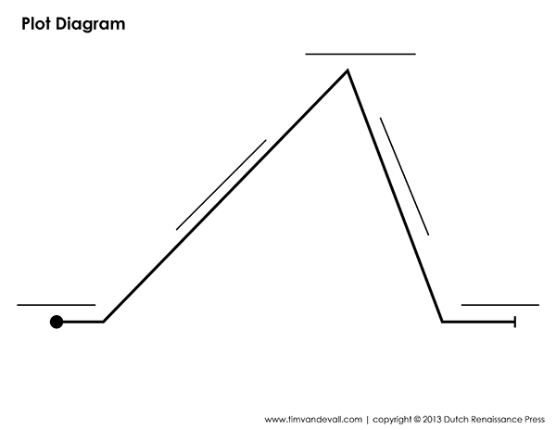
Directions: Label the plot diagram on this page by placing the following terms in the correct order: resolution, rising action, falling action, exposition, and climax.

Step 3: Plot Described
Directions: Within the boxes on the page below label and explain each part of the movie’s plot (the first box is labeled for you).
Exposition
CONFLICT

The plot diagram and plot work around some sort of conflict. There can be multiple conflicts in a story. Characters have to face a conflict and work to get around or find a solution for the conflict.

