Disney Movie Project
Demonstrating Understanding of Story Elements
This project is a final assessment for the elements of a story. Instead of taking a test, you will complete this project on your own. This project is due on January 6, 2016. If you don’t want to do work over the break, work on it before break begins! If you have any questions please do not hesitate to contact me at ben.schilling@chatthillscharter.org or view helpful information at my website http://schillingb.weebly.com/english-language-arts.html.
In order to complete this project, you will need to watch one animated Disney movie. Some movie suggestions include: Pixar movies like Finding Nemo, Aladdin, Jungle Book, and Cinderella. After selecting your movie, complete these assignments while you watch the film. I recommend having the remote handy so you can pause. If you don’t own any animated Disney movie, check one out at the local library or look for one online.

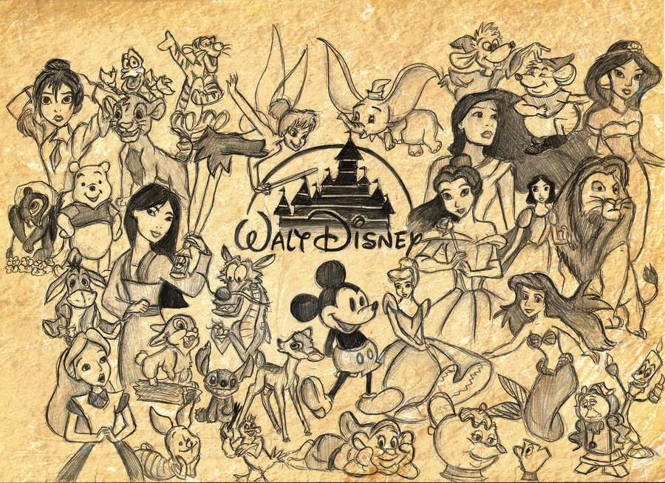
Project is due on January 6, 2016. This is the first day back to school for students.
Instructions & Rubric for Grading
Step 1. Design a front cover and attach it to the pages you receive in this packet. Include artwork and the name of the movie. Also make sure to include your name, the assignment title, and your class (ELA1 or ELA2).
Step 2. Label the plot diagram provided on page 3 by placing the following terms in the correct order: resolution, rising action, falling action, exposition, and climax.
Step 3. Within the boxes on page 4 label and explain each part of the movie’s plot (the first box is labeled for you).
Step 4. Write the definition of each italicized term and then answer the questions that follow (on pages 5-7). Make sure you are answering all questions in complete sentences. Definitions do not need to be in complete sentences.
Step 5. Use the Tic-Tac-Toe on page 8 to decide which three assignments to complete as part of this project. This is Tic-Tac-Toe! Your assignments need to be three in a row!

RUBRIC | 3 | 2 | 1
Step 1 – Cover | Includes all 5 elements from step instructions above | Includes only 3-4 elements from the step instructions above | Includes only 1-2 elements from the step instructions above
Step 2 – Plot Diagram | All 5 labeled correctly | 3-4 labeled correctly | 1-2 labeled correctly
Step 3 – Plot Described | All 5 labeled and explained correctly | 3-4 labeled and explained correctly | 1-2 labeled and explained correctly
Step 4 - Definitions | All terms defined and questions answered | Most terms defined and questions answered | Few terms defined and questions answered
Step 5 – Tic-Tac-Toe | Three assignments completed fully | Two assignments completed fully | One assignment completed fully
Spelling | No more than five errors in spelling | Five-ten errors in spelling | More than ten errors in spelling
Grammar | No more than five errors in grammar | Five-ten errors in grammar | More than ten errors in grammar
Punctuation | No more than five errors in punctuation | Five-ten errors in punctuation | More than ten errors in punctuation
Neatness | Project is readable | Project has some areas that are hard to read | Project is very hard to read

Final Score: ____________________ / 27
Percentage: ____________________ %
Step 5: Tic-Tac-Toe
Directions: Pick three of the assignments from the tic-tac-toe board below. These three assignments MUST be in a row. They can be vertical, horizontal, or diagonal.
Draw a picture of a character from the film | Create a movie poster for the film (like you’d see in a movie theater) | Create a unique movie trailer for the film using the things you learned from Mr. Robinson
Create a movie trailer for the film using the things you learned from Mr. Robinson | Create a new character and explain their role in the film | Draw a picture of a character from the film
Make a list of 10 characters from the film. Divide them into protagonists and antagonists. Write a short paragraph for each character explaining why they are a protagonist or antagonist in the story | Draw a picture of a character from the film | Create a movie poster for the film (like you’d see in a movie theater)
List your three choices below:
1.
2.
3.
Step 2: Plot Diagram
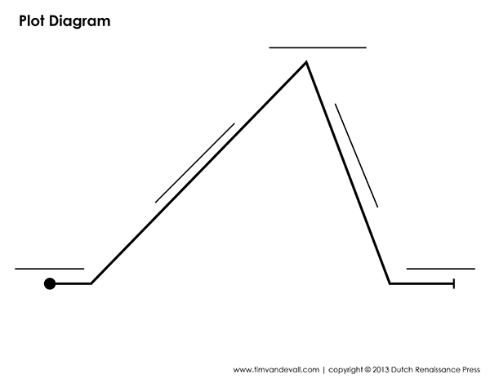
Directions: Label the plot diagram on this page by placing the following terms in the correct order: resolution, rising action, falling action, exposition, and climax.

Step 3: Plot Described
Directions: Within the boxes on the page below label and explain each part of the movie’s plot (the first box is labeled for you).
Exposition
CONFLICT

The plot diagram and plot work around some sort of conflict. There can be multiple conflicts in a story. Characters have to face a conflict and work to get around or find a solution for the conflict.

