Design a Shirt

Directions: Design a t-shirt that will convince others to help solve one of Africa’s environmental issues.
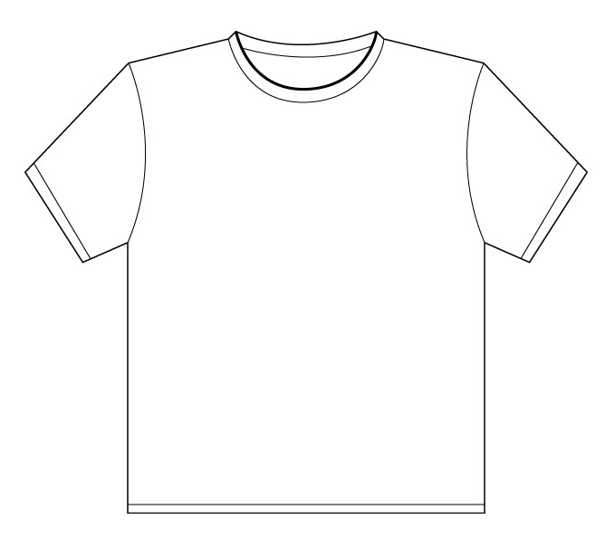
- Create a slogan for the shirt. This needs to be a thoughtful message or statement that describes the environmental issue and how it can be solved.
- Draw a colorful visual for the shirt.
- On the back of this paper, write a paragraph to describe the environmental issue and your ideas for how it can be solved.

