Columbian Exchange Semester Group Project

Project Directions:
You will be given two days in class to complete this assignment. On day one you should use the chart provided to you as well as your technology to research the Columbian Exchange and the goods transported during the exchange. Then use the information below plus your research to create a poster demonstrating the Columbian Exchange. Make sure to include visuals (pictures) as well as text (words). The important thing to consider is sharing the work load. Divide up the work so that you get the project completed. Some of you should be researching while others are preparing the poster. Follow the rubric and you’ll do GREAT!

Rubric: Project….
Is neat and organized | 10 points
Has visuals and text | 10 points
Shows all required plants | 20 points
Shows all required animals | 20 points
Shows all required diseases | 20 points
Has maps and diagrams to demonstrate the movement from New World to Old World | 20 points
 | Total Points = 100 | Total Points =
The Columbian Exchange
The Global Market from and to the Americas
Between the years 1540 and 1760 ships left from Europe to Latin America and then back to Europe. Those ships were the envoys of the so-called ‘Columbian Exchange’. The movement of foods and peoples between the so called ‘new’ and ‘old’ worlds brought tremendous historical changes.
‘El galeón Manila’ was made of mahogany and it was Spain’s largest ship. It would depart from Manila in the Philippines, on to Japan and down the West coast to the Americas. It carried Spanish goods to Veracruz, then overland to Acapulco and then back to Spain stopping on the way in Havana (Cuba), and again in Manila before arriving to Seville, its final destination.
The market in Manila was known as the ‘Parián’ and it was the richest and most varied market in the world. Traders from China, India and West Africa met in Manila to trade spices, silks, foods and slaves. From Spain they brought Mexican silver pesos. Mexican pesos were the main currency all over India, China and the West coast of Africa until World War II!! The market was so well known that Mexico City started its own market following the model and even gave it the same name.
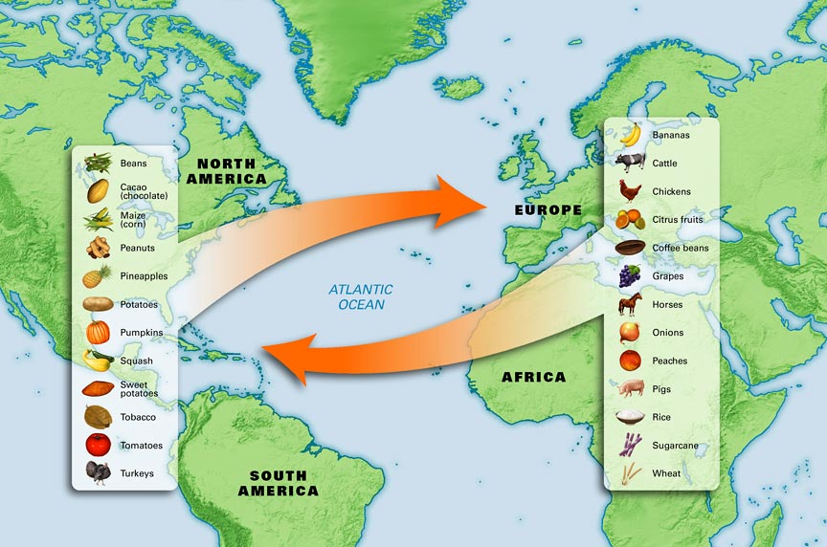
Information for your Poster
Exploration 1: Origins of Plants (36)
Identify where the following plants originated:
- avocados  - bananas  - barley  - beans  - cacao (source of Chocolate)  - chicle (source of Chewing Gum)  - clover  - coffee  - corn  - daisies  - dandelions  - grapes  - guavas  - Kentucky bluegrass  - lemons  - manioc  - melons | - oats  - olives  - papayas  - peach  - peanuts  - pear  - peppers  - pineapples  - potatoes  - pumpkins  - radish  - ragweed  - rice  - squash  - sugar/sugarcane  - sweet potatoes  - tobacco  - tomatoes  - wheat

Exploration 2: Origins of Animals (10)
Identify where the following animals originated:
- horses  - pigs  - cattle  - sheep  - goats | - chickens  - turkeys  - llamas  - alpacas  - guinea pigs

Exploration 3: Origins of Diseases (9)
Identify where the following diseases originated:
- smallpox  - bubonic plague  - syphillis  - measles  - chicken pox | - malaria  - yellow fever  - influenza  - the common cold

Definitions:
plants - plants include trees, bushes, herbs, ferns, mosses, and certain green algae
animals - any of numerous multicellular eukaryotic organisms of the kingdom Animalia that ingest food rather than manufacturing it themselves and are usually able to move about during at least part of their life cycle
diseases - illness or sickness in general
originated - where something is found naturally

