Bumper Sticker
Your Task: Create a bumper sticker with a short statement or message that is for or against NAFTA (your personal opinion).

The bumper sticker MUST have:
1. Thoughtful message or statement describing your position on NAFTA.
2. Colorful visual
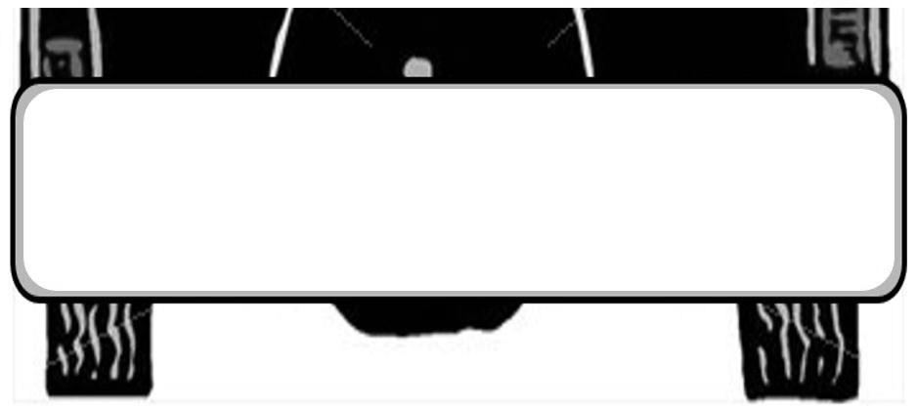
3. On the back, in a well-developed paragraph, describe the issue and your ideas for how it can be solved.

