Build-a-Biography
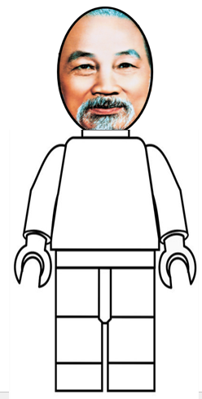
Directions: Complete the graphic organizer below with information and facts about Ho Chi Minh.
HEAD: What did he strongly believe in?
HEART: What was he passionate about?
FEET: What are some setbacks or challenges that he faced?
HANDS: What did he accomplish? How did he contribute to history?
MOUTH: What is something that he would say? (Not an actual quote-you make this up!)
EYES: What did he hope to see in the future?

