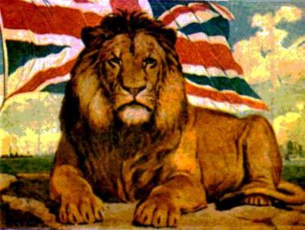N

**POWER**

* **__________ gained power**
* **__________ regarded as most ____________ nation**
* **Power meant NO ________________**
* **British could ___________ opposition**

**COLONIZATION**

* **Allowed people to begin _________ __________**
* **_____________ poverty**
* **___________ came to escape hunger**
* **Began in ___________**
* **______________ moved to Australia each year**

SS6H6(c) Trace the colonization of Australia by the United Kingdom

Name: ______________________________

**PRISON**

* **Founded as a ____________ colony**
* **Most settlers were guilty of ____________crime**
* **_____________ prisoners sent to the colony**

**GOLD RUSH**

* **Discovery of ________________ caused more migration**
* **__________ __________ became wealthy**
* **As white population grew, _______________ population decreased**

**TRADE**

* **Economic growth due to ________ and _________**
* **Debates between __________ and British ___________**
* **Over __________ and _________ ____________**

**STRATEGIC IMPORTANCE**

* **A ________ for the navy in southern Pacific Ocean**
* **Britain was able to be versatile in the _________ of ships to nearby areas**

**COLONIZATION OF AUSTRALIA**