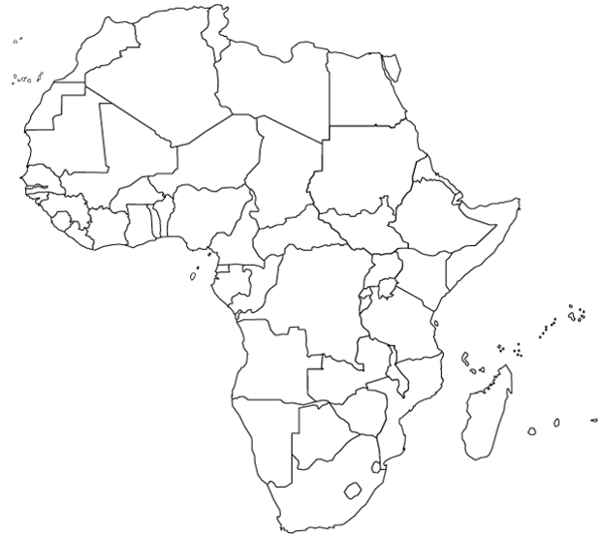

Label the Landforms onto the map
Niger River
Nile River
Sahara
Sahel
Lake Victoria
Lake Tanganyika
Atlas Mountains
Congo River
Kalahari Desert
Label the Countries onto the map
Sudan
Kenya
South Sudan
Democratic Republic of the Congo
Nigeria
Egypt
South Africa

